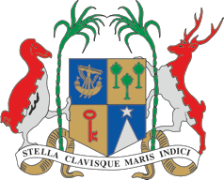
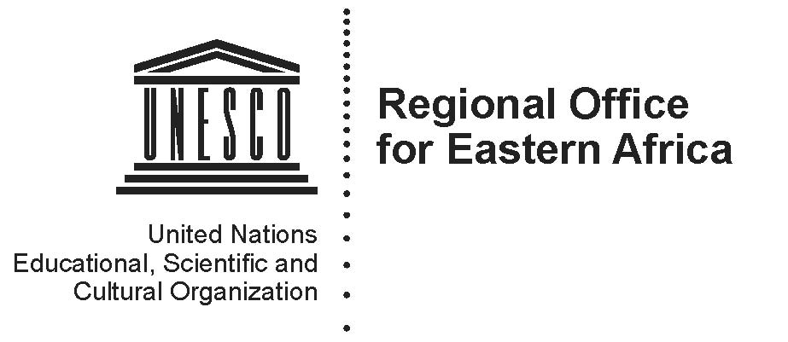
Ministry of Arts and Culture
Republic of Mauritius

STATEMENT
REGIONAL MINISTERIAL ROUNDTABLE ON STRENGTHENING SYNERGIES FOR CULTURAL HERITAGE PROTECTION IN EASTERN AFRICA
AND THE ADJACENT INDIAN OCEAN ISLAND STATES
20 July 2017
Balaclava, Republic of Republic of Mauritius

We, the Ministers and the Heads of Delegations from the State of Eritrea, Federal Democratic Republic of Ethiopia, Republic of Djibouti, Republikan'i Madagasikara (Madagascar), Republic of Mauritius, Republic of Seychelles, Federal Republic of Somalia and Republic of South Sudan together with representatives from Union of Comoros, Republic of Kenya, United Republic of Tanzania, Republic of Uganda, responsible for the safeguarding and promotion of Cultural Heritage in Eastern Africa and the adjacent Indian Ocean Island States, together with representatives from the Democratic Republic of Congo from the Central Africa Region and Regional Economic Communities (IGAD, EAC), and other partners, on the occasion of the Ministerial Roundtable to Strengthen Synergies for the Protection of Cultural Heritage in the region, organized in Balaclava, Republic of Mauritius, on 20 July 2017, by UNESCO in collaboration with the Government of the Republic of Mauritius,

Taking note with satisfaction of the Recommendations of the Regional conference on the protection of cultural heritage in Eastern Africa and the adjacent Indian Ocean Island States, which took place on 18 and 19 July 2017 in Moka, Republic of Mauritius,

Aware of the increasing threats to cultural heritage from conflicts, terrorism and disasters, which are also negatively affecting the cultural identity and resilience of internally displaced people, refugees and migrants in the region,

Recognizing access to cultural heritage and participation in cultural life as integral components of human rights, as well as the fundamental role of culture in strengthening resilience and supporting stability, harmony and peace,

Acknowledging the fundamental role of culture and cultural heritage in conflict prevention and peace-building through the promotion of intercultural dialogue and social cohesion,

Convinced of the need for culture to be included in national plans for development in the region as well as the need for improved policies to protect and promote cultural heritage,

Recalling the UNESCO Constitution adopted on 16 November 1945 “to contribute to peace and security by promoting collaboration among the nations through education, science and culture in order to further universal respect for justice, for the rule of law and for the human rights and fundamental freedoms,”

Also recalling the Vision of the African Union for “an integrated, prosperous and peaceful Africa, driven by its own citizens and representing a dynamic force in the global arena,”

Recognizing the role of the African Regional Economic Communities in the protection, conservation and promotion of cultural heritage,

Upholding the continued relevance of the Cultural Charter for Africa, adopted by the Heads of State and Government of the Organization of African Unity in Port Louis, Mauritius on 5 July 1976,

Emphasizing the need of implementing the United Nations 2030 Agenda for Sustainable Development and the African Union’s Agenda 2063: The Africa We Want, which provide a roadmap for safeguarding and promoting cultural heritage for sustainable development,

Referring to the adoption by the United Nations General Conference in 2015 of the Sendai Framework for Disaster Risk Reduction (2015-2030), which recognizes the need to support the protection of cultural institutions and cultural heritage sites,

Welcoming the Strategy for Reinforcing UNESCO's Action for the Protection of Culture and the Promotion of Cultural Pluralism in the Event of Armed Conflict, adopted by the UNESCO General Conference in November 2015, as well as its Action Plan, which includes consideration of disasters caused by natural and human-induced hazards,

Applauding the efforts of the United Nations Security Council on the protection of cultural heritage, in particular the adoption of its Resolutions 2199 (2015), 2253 (2015) and 2347 (2017),

Commending the adoption by the Human Rights Council in September 2016 of Resolution 33/20 on “Cultural rights and the protection of cultural heritage”,

Taking note of the “Florence Declaration”, adopted at the March 2017 G7 Culture Ministers’ meeting, which recognizes the distinctive role of culture as an instrument for dialogue, reconciliation and response to emergency situations; and calls for common and coordinated action to strengthen the safeguarding of cultural heritage,

Recognizing the importance of becoming party to and implementing the international legal instruments for the protection of cultural heritage (UNESCO 1954, 1970, 1972, 2001, 2003, 2005 and UNIDROIT 1995)

Noting the urgent need to safeguard cultural and natural heritage within a sustainable development framework in Eastern Africa and the adjacent Indian Ocean Island States with the participation of youth,

Hereby agree to:

1) Join in the Global Coalition “#Unite For Heritage” launched by UNESCO in 2015 to raise awareness in the region and strengthen joint actions for the protection of culture and cultural heritage in crisis and emergency situations;

2) Consider becoming party to relevant international normative instruments in the field of cultural heritage protection and strengthening their implementation nationally and regionally;

3) Reaffirm our commitment to safeguard cultural and natural heritage, tangible and intangible, movable and immovable; first and foremost by promoting the inclusion of Culture in our respective National Plans for Development; secondly by strengthening regional collaborations in Eastern Africa and the adjacent Indian Ocean Island States; and thirdly by considering the integration of culture into disaster risk reduction, humanitarian, security and peace building policies and operations in the region, including in the framework of United Nations and African Union mechanisms;

4) Recognise the need for enhancing domestic criminal legislation to sanction crimes committed against cultural property;

5) Acknowledge the role of the World Customs Organization and INTERPOL in fighting illicit trafficking in cultural heritage, the necessity to use and contribute to the INTERPOL Database of Stolen Works of Art, and encourage the establishment of a specialized national police unit for the protection of cultural heritage;

6) Recognize the urgent need to establish and regularly update inventories for the protection of cultural heritage and the fight against illicit trafficking of cultural property;

7) Call upon UNESCO, its partners, and the international community to provide assistance, within their mandates and resources, to strengthen the protection of cultural heritage in Eastern Africa and the adjacent Indian Ocean Island States.

Adopted on 20 July 2017 in Balaclava, Republic of Mauritius

